Homework for week 3, submission deadline 23:59 on Sunday night.
- Use nature microbiology paper from last week and use a GSE identified from Week 2 homework, answer the question list in the table below. If you use AI-agent or R to facilitate this process, please paste code or script at the end.

Nature Microbiology- 2022 - Sambhawa Priya - Identification of shared and disease-specific host gene–microbiome associations across human diseases using multi-omic integration
公开数据集编号：GEO GSE111889
Step | Student action | Evidence to record
1 | State the Week 2 data-driven question. | 在 IBD 患者结肠黏膜中，比较炎症与非炎症组织、IBD 与非 IBD 对照，观察宿主基因表达与黏膜菌群组成的关联模式，数据类型为 bulk RNA-seq（宿主）+ 16S rRNA（菌群）配对多组学数据
2 | Confirm study identity. | GES：GSE111889  Title：Longitudinal Multi’omics of the Human Microbiome in Inflammatory Bowel Disease  Organism：Homo sapiens  Publication：Lloyd-Price J et al., Nature 2019；Priya et al., Nature Microbiology 2022  Platform：GPL11154 Illumina HiSeq 2000
3 | Map accessions. | GSM：GSM3043377  BioProject：PRJNA438663  SRP / SRR：此数据集无公开的SRA Run Selector链接，原始数据未存放在SRA
4 | Identify available data layers. | Series matrix：GSE111889_series_matrix.txt.gz  Supplementary counts：GSE111889_host_tx_counts.tsv.gz  Raw reads：无公开的原始reads。数据因隐私保护提交至dbGaP，非公开访问  Single-cell files：不是单细胞研究
5 | Reconstruct the design. | Groups：  1. Crohn's Disease (CD)  2. Ulcerative Colitis (UC)  3. Non-IBD control  n：  总样本数：251  CD：127  UC：74  Non-IBD：50  Female：139 / Male：112  subject/paired structure：  仅根据代码输出结果与GEO metadata判断存在纵向/配对结构，但 GEO metadata 未直接提供 Subject ID  major covariates：  1. 性别（Female / Male）  2. 活检部位（Ileum 89, Rectum 100, Sigmoid Colon 22, Transverse colon 14, Ascending colon 8, Descending colon 9, Cecum 5, Terminal ileum 3, Non-inflamed 1）  batch：  GEO metadata 中未发现显式 batch 列，需参考原始论文

- GSE87487 is a human bulk RNA-seq study of 20 liver allograft biopsies, with pre- and post-reperfusion sampling and a 3.7 MB supplementary count matrix. The Series links to SRA project SRP090633. If you use AI-agent or R to facilitate this process, please paste code or script at the end.
Question | Student decision
Are the values counts? | 下载 count matrix 并用 R 读取并检查。矩阵维度为 60498 行 × 20 列，对所有 20 个样本进行整数检查，结果均为 TRUE，确认全都是非负整数，属于原始 raw counts
Are samples independent? | 根据样本列名（如 Sample_Pt10-Bx1 和 Sample_Pt10-Bx2），可以清楚看出该研究包含 10 个受试者，每个受试者都采集了配对的 pre-reperfusion 和 post-reperfusion 样本。因此样本不独立
Can all 20 samples be compared directly? | 不能直接比较，因为20 个样本是 10 对配对样本，直接混合比较会犯伪重复的错误。分析前必须定义具体对比
Is full raw-read reprocessing possible? | 理论上是可行的，因为Series 链接到了 SRA 项目 SRP090633，原始 reads 公开可获取，可以做到完整重跑

第一题中使用的R代码及其输出如下：
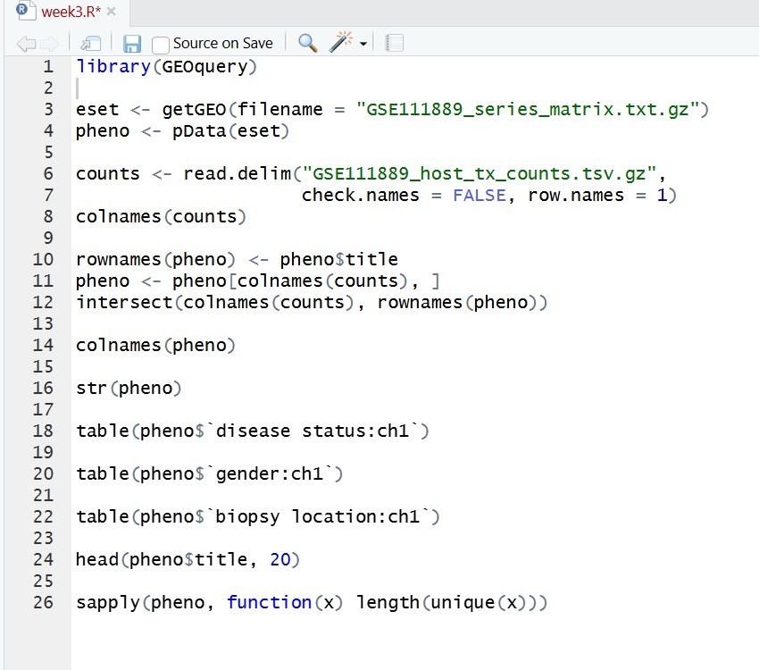
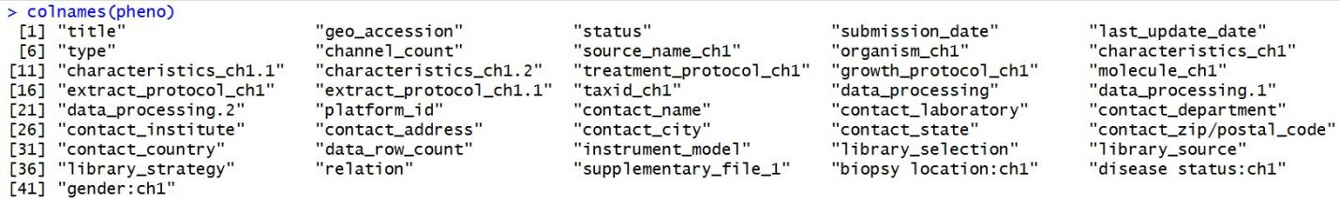
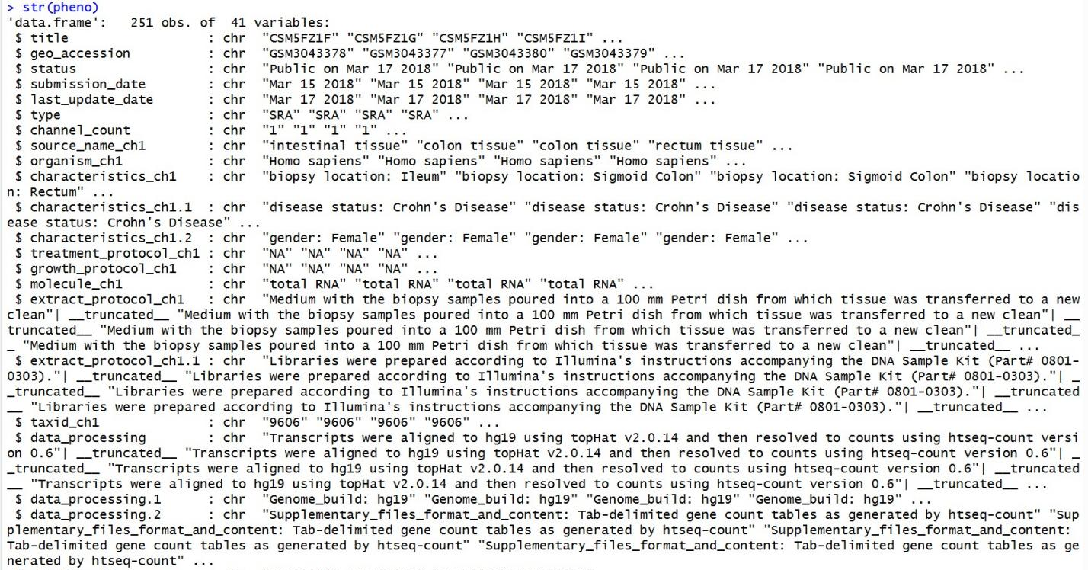
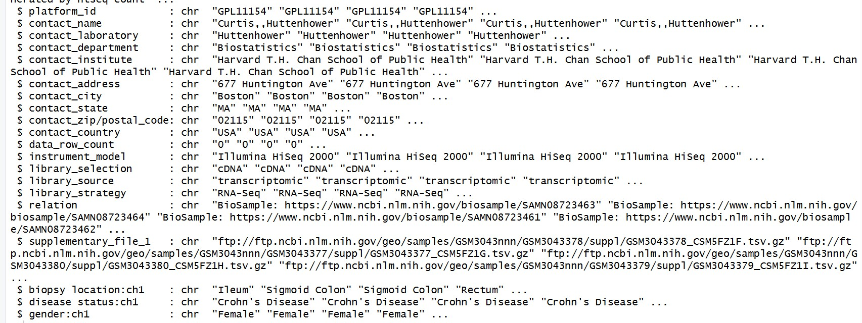
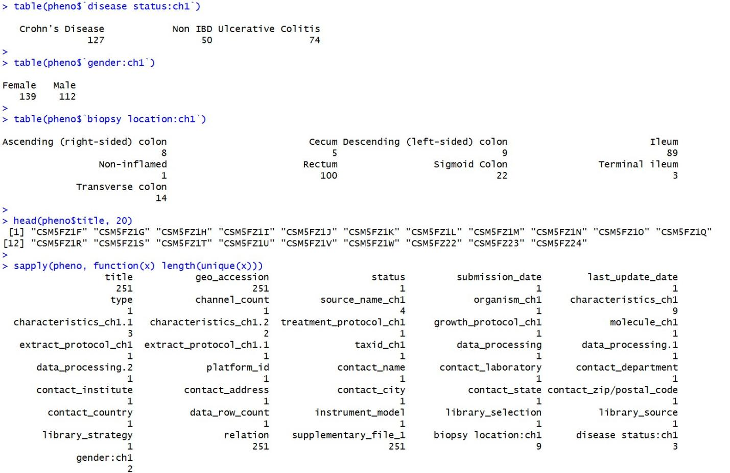
第二题使用到的R代码与运行结果如下：
